public class Piramide {

/**

* @param args the command line arguments

*/

public static void main(String[] args) {

// TODO code application logic here

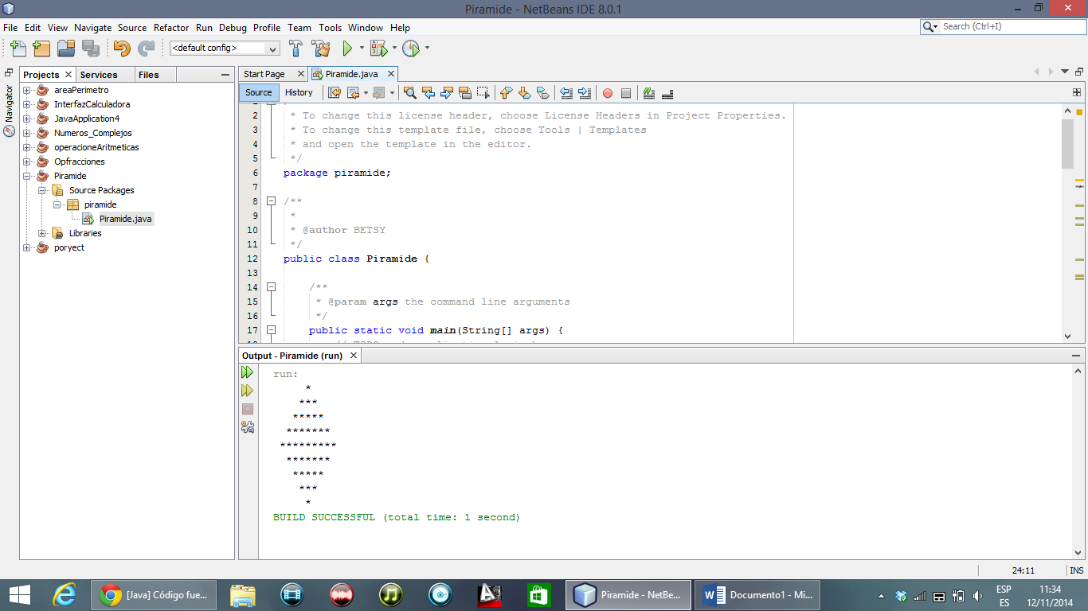

int i=0,j=0,k=0;

for(i=0;i<=9;i++)

{

if(i%2==1)

{

for(k=10;k>=i;k--)

{

if(k%2==1)

{

System.out.print( " " );

}

}

for(j=0;j<i;j++)

{

System.out.print( "*" );

}

System.out.println( );

}

}

//parte de abajo

for(i=9;i>1;i--)

{

if((i%2)==1)

{

for(k=i;k<=11;k++)

{

if((k%2)==1)

{

System.out.print( " " );

}

}

for(j=i-2;j>0;j--)

{

System.out.print( "*" );

}

System.out.println( );

}

}

}

}

# include <iostream>

using namespace std ;

int main ()

{

int n ;

cout << " Ingrese un numero : " ;

cin >> n ;

for (int j = 0; j < n ; ++j) {

for (int i = 0; i < n-j-1; ++i)

cout << " ";

for (int i = 0; i < 2*j+1; ++i)

cout << "*" ;

cout << endl ;

}

for (int j=n-2; j>=0; --j) {

for (int i=0; i<n-j-1; ++i)

cout << " " ;

for (int i=0; i<2*j+1; ++i)

cout << "*" ;

cout << endl ;

}

system("pause");

return 0;

}

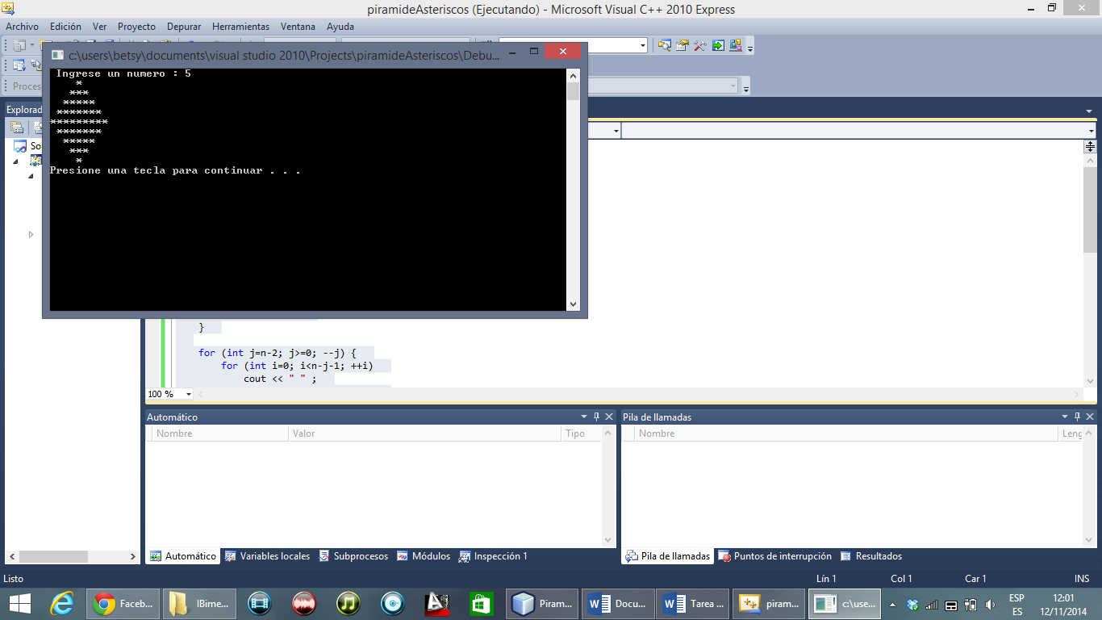

# include <iostream>

using namespace std ;

int main ()

{

int a ;

cout << " Ingrese un numero : \n" ;

cin >> a ;

for (int j = 0; j < a ; ++j) {

for (int i = 0; i < a-j-1; ++i)

cout << " ";

for (int i = 0; i < 2*j+1; ++i)

cout << "*" ;

cout << endl ;

}

for (int j=a-2; j>=0; --j) {

for (int i=0; i<a-j-1; ++i)

cout << " " ;

for (int i=0; i<2*j+1; ++i)

cout << "*" ;

cout << endl ;

}

system("pause");

return 0;

}

S

PIRAMIDE EN JAVA

MAIN

package piramide;

import java.util.Scanner;

/**

*

* @author BETSY

*/

public class Piramide {

/**

* @param args the command line arguments

*/

public static void main(String[] args) {

// TODO code application logic here

ClsAsterisco obj= new ClsAsterisco ();

obj.rom();

}

}

CLASE ROMBO

package piramide;

/**

*

* @author BETSY

*/

import java.util.Scanner;

public class ClsAsterisco {

private int a=9;

public void rom(){

Scanner obj= new Scanner (System.in);

int x=2;

while(x % 2 ==0)

{

System.out.println("Ingrese numero de lisa q tendras en el rombo ");

//el numero debe ser impar

x= obj.nextInt();

}

a=x;

for(int i=1 ;i<=((a/2)+1); i++){

for (int k=1; k<=a/2-i+1;k++)

System.out.printf(" ");

for(int j= (a/2)-i+2;j<=(a/2)+i; j++)

System.out.printf("*");

System.out.println("\n");

}

for(int l=1;l<=a/2;l++){

for(int m=1; m<=l;m++)

{

System.out.print(" ");

}

for(int n=l+1; n<a-l; n++)

System.out.printf("*");

System.out.println();

 



